4/06/2020

The processes set out below are an example of one Region’s plan to ensure the health and wellbeing of all Employee-Owners, while reducing risk as quickly as possible each and every morning.

They are posting QR code posters at the jobsite as well as handing out cards with HR’s
contact information with the jobsite QR code on the back of them to all employees to place in their vehicles or wallets and utilize prior to coming to the jobsite.

These QR codes take each EO to an online portal where the team can quickly assess the risk all employees attempting to enter the jobsite. By doing this prior to their arrival, it reduces interactions, as well as allows the Project Manager and their team to react quickly to an individual that may put the jobsite at risk.

Creating the questionnaire
- Click on the template version link here
- At the top ribbon – click “Duplicate it” 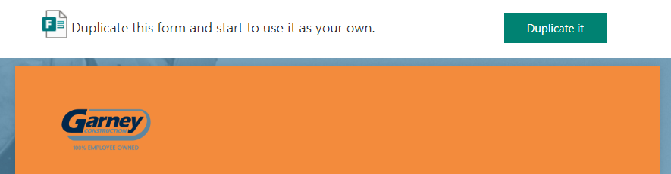
- This will create a new microsoft form with the title changed to include (Copy) in it (this Word can be deleted if desired)- it is already saved to your Office 365 so no saving needs to happen from this point on
- Click into Question #1 to edit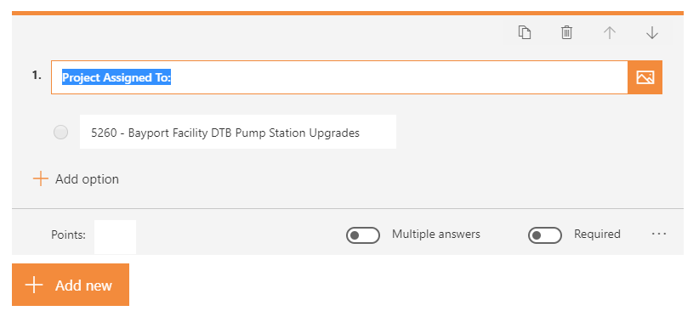
- Change project number and name to your project information
- Click into Question #2 to edit 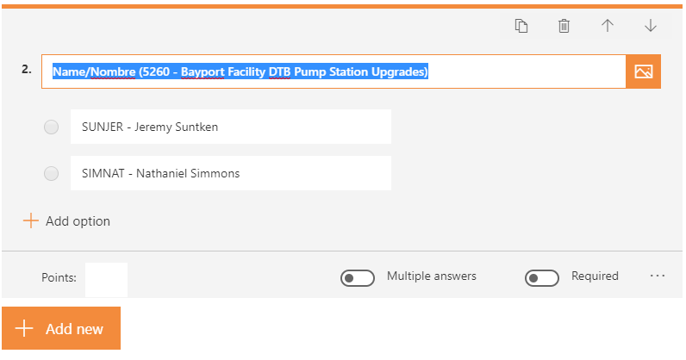
- Click into the SUNJER or SIMNAT line item and Change to your Employee Code for each of your Employees (Salary and Hourly), add a space, a dash, and another space before typing their name that is in spectrum (potentially not the name they go by)
- If additional spaces are needed, the orange “add Option” will give you an unlimited amount of lines.
- If you need to delete a line, you can click into the line you want to delete and click the trashcan next to each line that looks like this 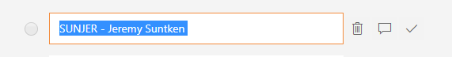
- All changes are saved immediately so there is no need to make any changes in addition to those listed above

creating a summary link for the designated site representative

- After you have created your own version of the questionnaire click “Responses” in the middle of the page

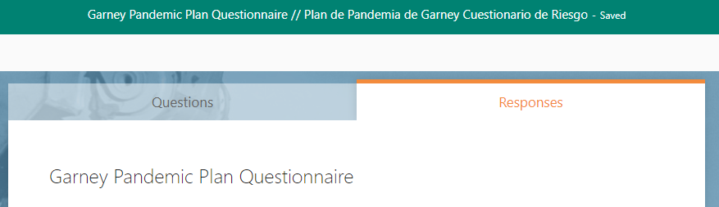

- Next click on the three horizontal dots just below the words “Active Status” 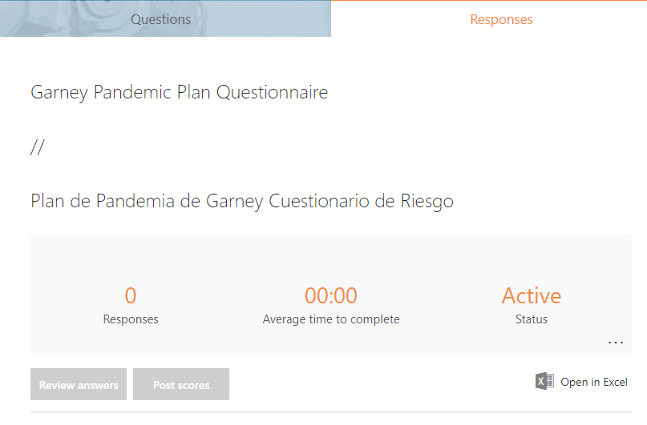

- Click “Create a Summary Link”

- Click “Copy” – This will copy to your clipboard, and can be emailed, texted, or printed out for your designated site representative to utilize as results come in almost instantaneously

- Under responses is where you can in real time view the results as well as open them in Excel (This is the view that your Summary Link will show whomever you share it with)

generating a qr code/contact buisness card for your questionnaire

- To create a qr code on the top right of the page click “share”

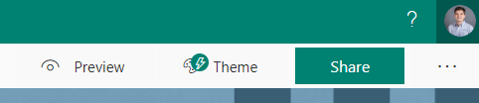

- Under share and “Send and Collect Responses” Select the second option and make sure that you see the words “Anyone with the link can respond”
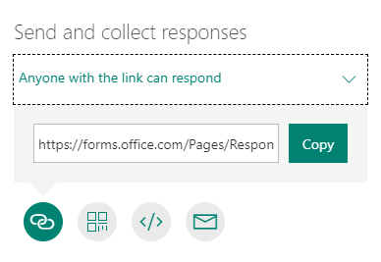
- Click Download

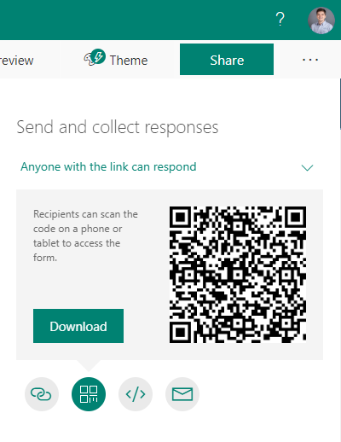

- This will create an Image that you can share, print, and post for your jobsite that takes everyone immediately to the questionnaire

implementation process

- Each Project will identify an entry location where all visitors, employees and subcontractors must notify a designated supervisor prior to accessing the jobsite (If on a pipe job, this could be the Superintendent’s vehicle or another easily identifiable point on the project.
- ALL visitors, employees, and subcontractors will affirm a “no” response to the questions when notifying a designated supervisor prior to entering the jobsite
- No one will be allowed to enter the jobsite until the site representative has confirmed the questionnaire results.
- If a visitor, employee, or subcontractor answer “yes” to any of these questions, they shall not be allowed on site.
- If an employee answer “yes” to any of the questions
- The employee should be asked to please leave the jobsite immediately
- The employee should contact HR@Garney.com or call (816) 746-7263 to document the specific issues as well as obtain further guidance on what actions are required.

